SERVER METRIC ANALYSIS

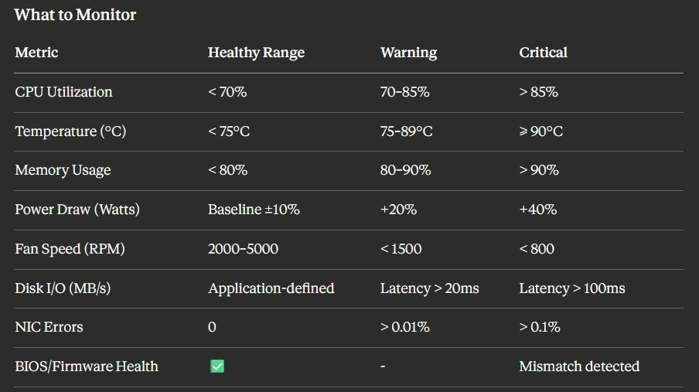

Server basics
- A server hosts workloads directly or runs a hypervisor for VMs
- It handles compute, storage, and processing tasks

Core Monitoring Metrics

🔹 CPU Utilization
- % of time CPU is actively working
- Higher % → more workload

🔹 Temperature
- Indicates system heat
- Increases with workload

🔹 Memory Usage
- RAM / virtual memory consumption
- High usage → possible bottleneck

🔹 Power Draw (Watts)
- Total power consumed by system
- Derived metric (not directly measured in your setup)

🔹 Fan Speed (RPM)
- Speed of cooling fans
- Indirect signal of system condition

🔹 Disk I/O (MB/s)
- Data transfer rate (read/write)
- Related to latency and storage performance

Power Concepts

🔹 Power Formula
- Power = Voltage × Current (Watts)

🔹 Key Idea
- Components pull power
- PSU does NOT push power

🔹 Power Draw
- Sum of power consumed by components:
  - CPU
  - RAM
  - Storage
  - Others

🔹 Derived Power Model (for the project)
- Power = Base
  - (CPU% × CPU_weight)
  - (Memory% × Memory_weight)

🔹 Base Power
- Power when system is idle
- Includes motherboard, idle CPU, fans

🔹 CPU Weight
- Maximum power CPU can consume

🔹 Memory Weight
- Approx power used by RAM

PSU (Power Supply Unit)
- Converts AC → DC
- Supplies power to components

🔹 PSU Capacity
- Maximum power it can supply (e.g., 750W)
- Not equal to power draw

🔹 Load %
- Load % = Power Draw / PSU Capacity

🔹 Ideal PSU Usage
- Best efficiency: 40–70% load

Fan Speed Insights
- Indicates cooling response
- Not directly controlled by workload

🔹 Relationship
- Workload ↑ → Power ↑ → Temperature ↑ → Fan Speed ↑

🔹 Key Points
- Fan speed ∝ Temperature
- Used to:
  - Show cascading effects
  - Detect anomalies

Disk Metrics

🔹 IOPS (Input/Output Operations Per Second)
- Number of read/write operations per second
- Indicates workload intensity
- Used in:
  - Databases
  - Microservices

🔹 MB/s (Throughput)
- Amount of data transferred per second
- Used in:
  - File transfers
  - Logs

🔹 Difference
- IOPS → number of operations
- MB/s → volume of data

System Understanding (Important)
- Power Draw is derived
- Fan Speed is reactive
- Disk I/O shows data activity
- CPU & Memory are primary drivers

